# Introduction

This chapter describes the key results of the analysis of the survey data gathered through online questionnaires. An invitation to participate in the survey had been sent to roughly 1,000 principal investigators who were selected based on an informed sampling of the same number of research projects funded by the SNSF. The response rate amounted to 36% and resulted in a fairly representative sample, balanced by gender and scientific domains.

This chapter describes the methodology, presents the key results of the statistical analyses, and lastly offers a model to approximate the contribution of SNSF-funded projects to social innovation (SI).

# Methodology

The chosen methodological approach is the product of extensive literature research and a series of discussions with experts on social innovation (SI). The overall methodological approach is described in previous chapters. This section focuses on the detailed description of methods applied, assumptions made, and decisions taken regarding the analysis of the survey data.

Almost all survey questions were posed to test specific hypotheses. While some served to test whether responses were significantly different between scientific domains[1], others served to examine relations/correlations between different variables covered by the survey questions.

Some of the variables showed too little variation for hypothesis testing (e.g. high similarity in age groups of the respondents makes the variable ineligible to base hypothesis on). That being said, the vast majority of hypotheses could be tested based on the survey results.

Before conducting statistical tests, the distributions of the survey questions were considered to decide the appropriate hypothesis testing methods. The responses to the survey items were not normally distributed, thus we used non-parametric statistical tests. We used Spearman correlations for testing associations between variables and … to test for differences between variables.

For the analysis, the hypothesis testing, as well as the visualisation of results, the statistical programming language R was used, as well as the occasional Python scripting.

Considering the rich number of the SI aspects, and in relation, to the wide scope of the survey questions, survey results have produced a fairly large dataset with a high number of features. For the model building, an extensive dimension reduction process comprising *Principal Feature Analysis* (PFA(Lu et al., 2007)) was applied to determine feature importance in order to eliminate the least *important* ones, furthermore, *Explanatory* and *Confirmatory Factor Analysis* (EFA, CFA) methods were used to represent a large number of features in a fewer number of factors. The representative model produced by the factor analysis process has been used as a basis to create an *SI-Index* that categorises the examined projects in terms of their contribution to SI.

The final hypothesis of the study concerns with the comparison of the SI-Index created through our modelling process and the contribution to SI-Rating entered by each survey respondent for their project (for a detailed analysis of the survey question, see Section 3.4: Contribution to SI (self-assessment)). The ambition for the comparison is to find out if there is any significant over- or understatement regarding the self-assessed SI-Rating.

# Analysis of the survey questions

## Familiarity with SI and Transdisciplinarity

Figure 1: The distribution of SI-familiarity, familiarity with transdisciplinarity and contribution to SI rate (self-assessment)

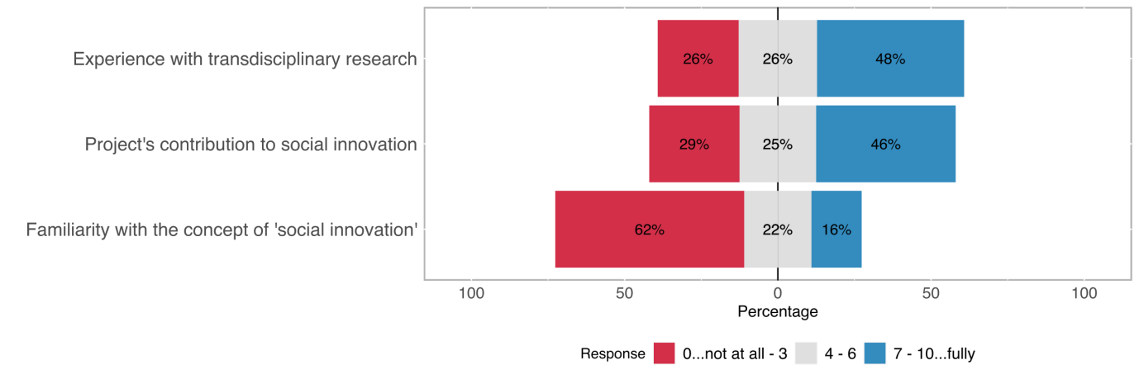

The survey started with questions about the respondents’ *familiarity with SI* and *experience with* *transdisciplinarity*. Transdisciplinarity is insofar an important concept in social innovation as it allows for *vertical* inclusion in the research project, fostering active participation of non-academic societal actor. For this reason, *transdisciplinarity* can be considered an important potential indicator for SI-relevant outcomes. In contrast to what is stated in SI literature[2], our theoretical framework does not consider *transdisciplinary involvement* as a necessary prerequisite for research projects to contribute to SI but we expect it to be more influential than other factors (see Section 2.1 for further exploration).

The majority of respondents (62 %) stated to be only slightly or not at all *familiar with SI*; only 16 % stated to be highly or fully familiar with the concept of SI. This variable is of particular interest when testing if researchers mainly belonging to a scientific domain are generally more familiar with the concept than researchers belonging to a different scientific domain (see Section 2.2).

The third variable in the group of self-assessments is the *project’s contribution to SI*. An especially interesting scenario is when respondents show a low level of familiarity with SI but a high level of contribution to SI as it makes it necessary to verify whether the claim is true (based on outcome variables presented below) or whether respondents overestimated their project’s contribution.

## Experience with transdisciplinary Research

Table 1: Distribution of the transdisciplinary experience

| **How would you rate your experience with transdisciplinary research?** | | |
| --- | --- | --- |
| **Answer** | **Count** | **Percentage** |
| 0..not experienced at all | 19 | 4.75% |
| 1 | 18 | 4.50% |
| 2 | 27 | 6.75% |
| 3 | 35 | 8.75% |
| 4 | 22 | 5.50% |
| 5 | 40 | 10.00% |
| 6 | 33 | 8.25% |
| 7 | 61 | 15.25% |
| 8 | 41 | 10.25% |
| 9 | 31 | 7.75% |
| 10..highly experienced | 47 | 11.75% |
| No answer | 14 | 3.50% |
| Not completed | 12 | 3.00% |
| Total (gross) | 400 | 100.00% |

Figure 2: Distribution of the transdisciplinary experience

## 

We are not considering the use of transdisciplinarity approaches in the project as a precondition for contributing to SI. That being said, it is usually an important factor in achieving or contributing to socially innovative outcomes. The transdisciplinary experience of the researchers does not directly imply higher levels of social innovation in the research project but [H] *we assume that it is often in relation with non-academic motivations* that played a role when designing the research project.

Figure 2: Relation between the transdisciplinary experience and non-academic motivation

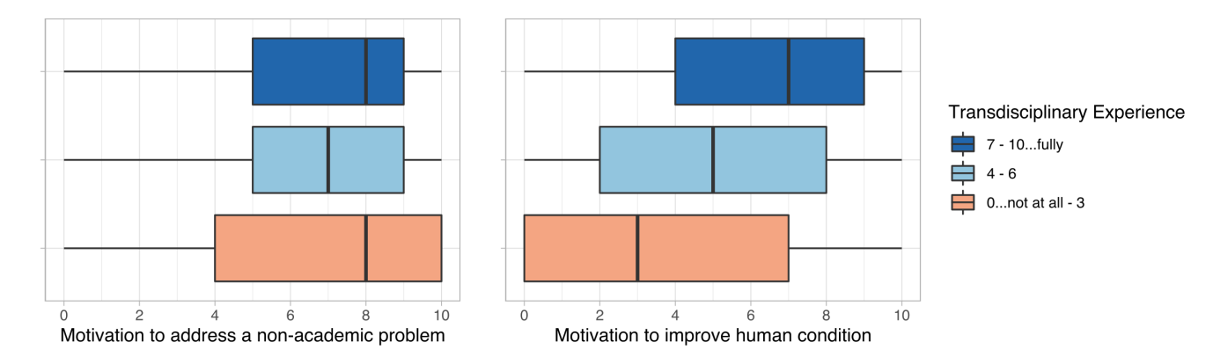

The purpose of the survey questions *motivation to* *directly address natural, technical, economic, or social problems* and *motivation* *to improve the human condition/welfare*[3] is to gauge motivation to create impact outside of academia.

The analysis of the relation between *transdisciplinary experience* and *the motivation to address a (non-academic) problem* (see Figure 2) does not yield a strong correlation (correlation coefficient rho[4] ~ 0.01). Moreover, the *motivation to address a natural, technical, economic, or social problem directly* does not seem to be getting higher with higher levels of *transdisciplinary experience*. The *motivation to improve the human condition* is, on the other hand, correlating relatively stronger with *transdisciplinary experience* – although it is statistically significant (p-value < 0.05[5]), there is only a weak positive correlation (rho ~ 0.33). Also, the *motivation to improve the human welfare/condition* is getting only slightly higher with a higher *transdisciplinary experience*.

## Academic Age

Figure 3: Distribution of academic age among the respondents

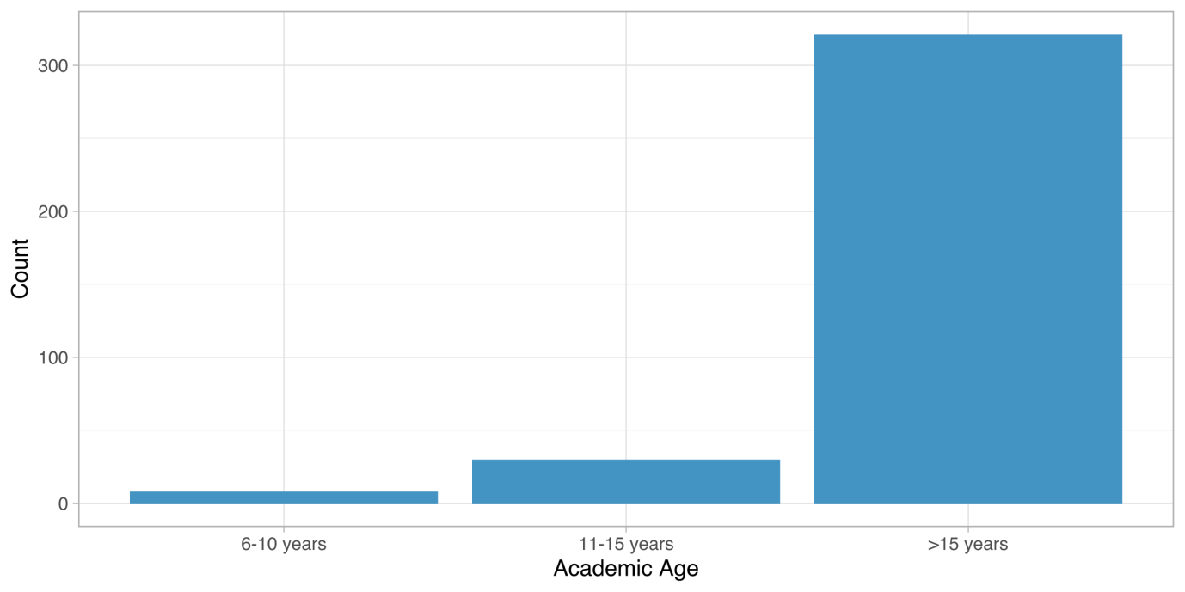

Examining academic age could have improved out understanding of the nature of SI. Unfortunately, academic age shows too little variation to play its role as almost 90% of the participants have over 15 years of experience in academia. This variable is therefore not used for hypothesis testing.

## Familiarity with social innovation

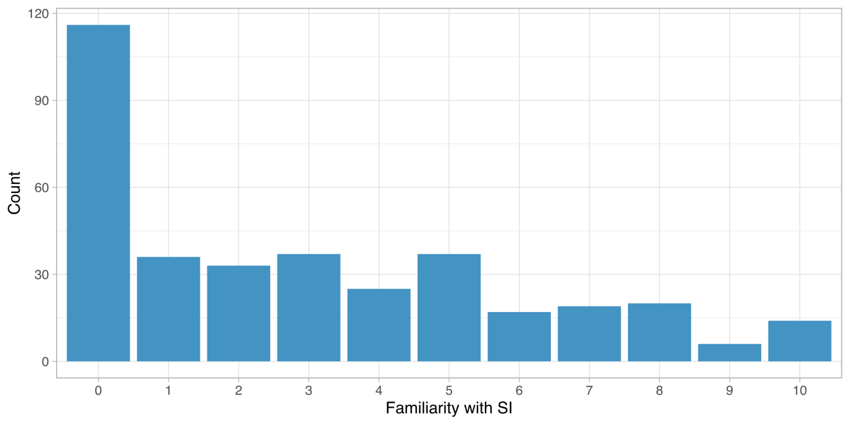

Figure 4: Distribution of the familiarity with social innovation

SI is a relatively little-known concept among the survey respondents. The majority indicated a low familiarity with the concept: ~ 32 % stated having a low or no *familiarity with SI* (<= 3 on a scale from 0 - 10); only 16 % of the respondents stated being highly familiar (>= 7).

One of the hypotheses based on the literature research about SI was that [H] *the SI-Familiarity depends on the scientific domain*, meaning that researchers belonging predominantly to a scientific domain tend to be more familiar than researchers belonging to another domain.

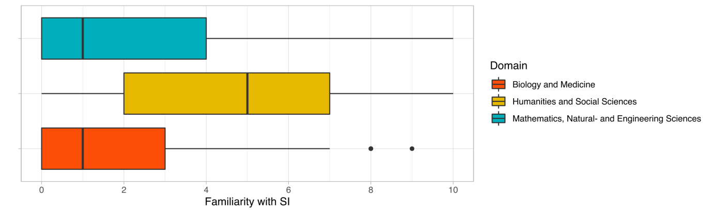

Figure 5: Distribution of the familiarity with SI among different scientific domains

The analysis of the survey results yields a statistically significant difference of the SI-familiarity between the scientific domains (Kruskal-Wallis[6] [K-W] rank-sum test p-value < 0.05). However, as Figure 4 also visualises and post hoc tests indicate, the domains Mathematics, Natural -, & Engineering Sciences and Biology & Medicine are statistically not significantly differ from each other while Social Sciences and Humanities (SSH) show a statistically significant difference to both of the other domains [7].

## Contribution to SI (self-assessment)

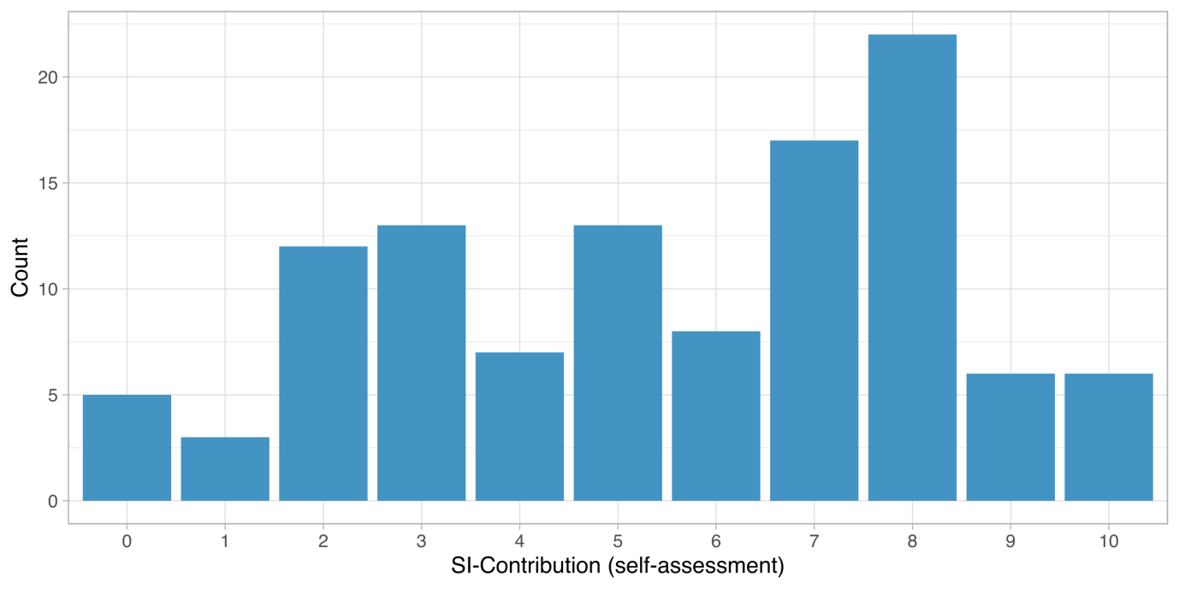

Figure 6: Distribution of self-assessed SI-Contribution

Respondents were asked about their project’s contribution to SI as a control variable, firstly, see the relation with the self-assessment and model[8] driven SI-Index, and secondly, to conclude if the self-assessment was generally overestimated.

The SI-Contribution is relatively more evenly distributed in comparison with SI-Familiarity. Over 50 respondents noted the SI-Contribution in their selected projects was equal to or higher than 7 and over 30 equal to or under 3 on a scale between 0 to 10. We are [H] expecting a slight overestimation of the SI-Contribution,

# Intention & Agency

## Motivation types

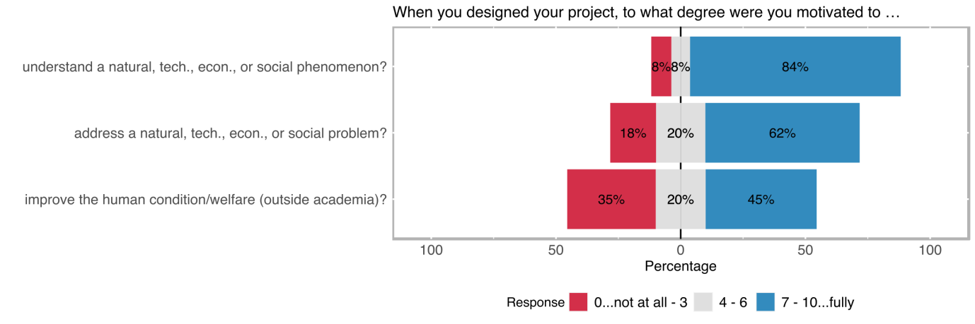

The type of motivation that drives academics to conduct research is an important indicator of the content, structure, and results of the study. The initial motivation types are measured in the survey using three main categories, namely, motivation to *better understand a natural, technical, economic, or social phenomenon* (purely academic motivation), to *directly address a natural, technical, economic, or social problem,* to *improve the human condition/welfare* (non-academic motivation).

The purely academic motivation was strongly emphasised in the survey results, 84 % of the survey respondents marked academic motivation greater or equal to 7 on a scale between 0 and 10. This was followed by motivation to directly address a problem with 64 % of the respondents noting equal to or higher levels than 7. Improving the human condition/welfare, the purely non-academic motivation, was more balanced in comparison. 35 % of the respondents replied with levels equal to or smaller than 3 and 45 % with levels equal to or higher than 7 in terms of improving the human condition/welfare being one of the main motivations in their research project.

Social innovation does not need to be driven by a socially-oriented motivation; purely academic research questions can lead to socially innovative outcomes as well. However, [H] we are expecting a significant correlation between the motivation to improve the human condition/welfare and the following outcome types[9] that indicate the direct contribution of the project results to new or better services, products, processes, or ways of doing things that were targeted towards:

* the general population,
* specific social groups (e.g., women/men/non-binary, youth/elderly; migrants; or minorities/indigenous people),
* NGOs, advocacy, or other civil society groups.

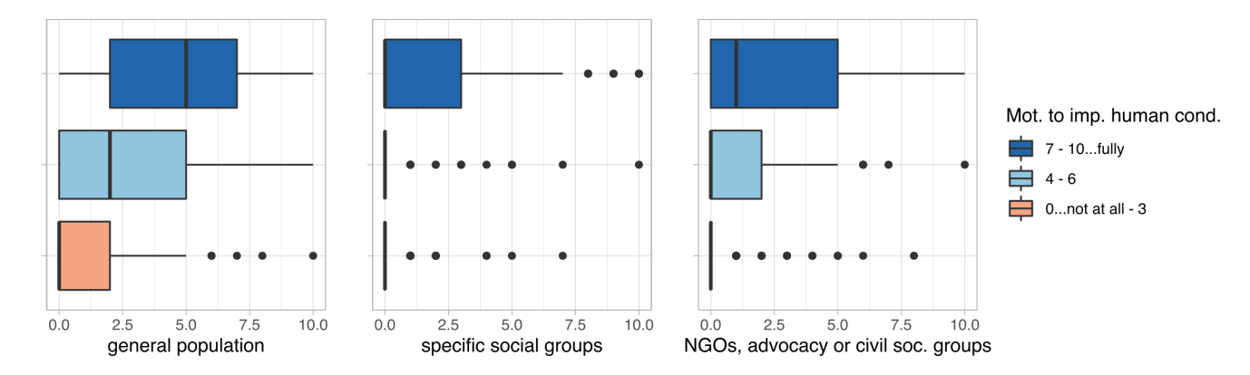

Figure 7: Relation between the motivation to improve the human condition/welfare and the direct contribution of the project results towards...

Motivation to improve the human condition shows statistically significant correlations with each of the outcome variables (p-values < 0.05). The strongest correlation is a moderate positive correlation with the direct contribution to new or better services, products, processes, or ways of doing things that were targeted towards the general population (rho = ~0.5).

## Intention to benefit non-academic world

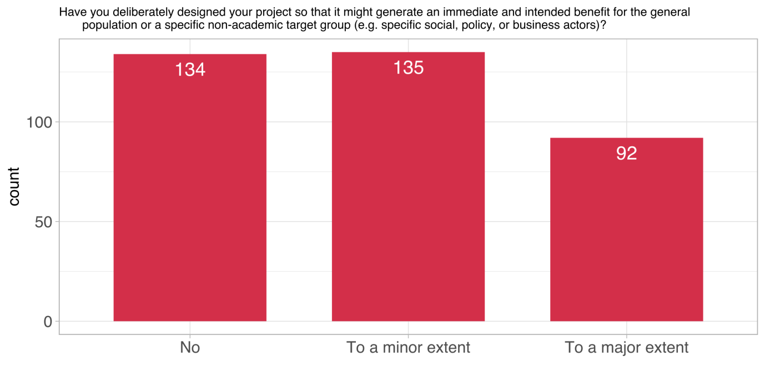

Figure 8: Distribution of impulses from the non-academic world

Following the non-academic motivation to conduct research, the variable *impulses from the non-academic world* targeted the research projects deliberatively designed to benefit a specific non-academic societal group. In this sense, the strive towards societal benefit is more emphasised in this particular survey question. Approximately 37 % of the respondents note that their projects were not specifically designed to benefit a social group. Almost exactly the same number of respondents indicated that this type of deliberative design was only present to a minor extent in their research project. Although a smaller proportion a significant part, 25 % of the respondents noted that the design of their projects was specifically targeted creating benefit for a social group.

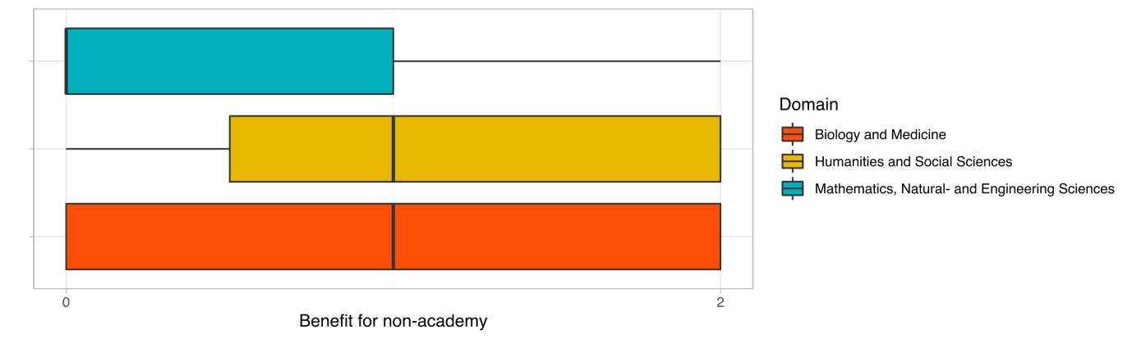

Figure 9: Deliberative design of the research for the benefit of non-academic groups among scientific domains

Similar to the familiarity with SI, differences of dependence of the deliberative design for social benefit among different domains is a

The deliberative approach to benefit for non-academic society shows a statistically significant difference between different domains (K-W p-value < 0.05), however, while there is a stat. significant difference between SSH and Physical Sciences as well as between Biology & Medicine and Physical Sciences, there is no stat. significant difference between SSH and Biology & Medicine (also visualised in Figure 7).

We also assume [H] *that the nature of the transdisciplinary involvement of the citizens in the research projects tends to be more active with higher levels of deliberative research setting towards societal benefit*.

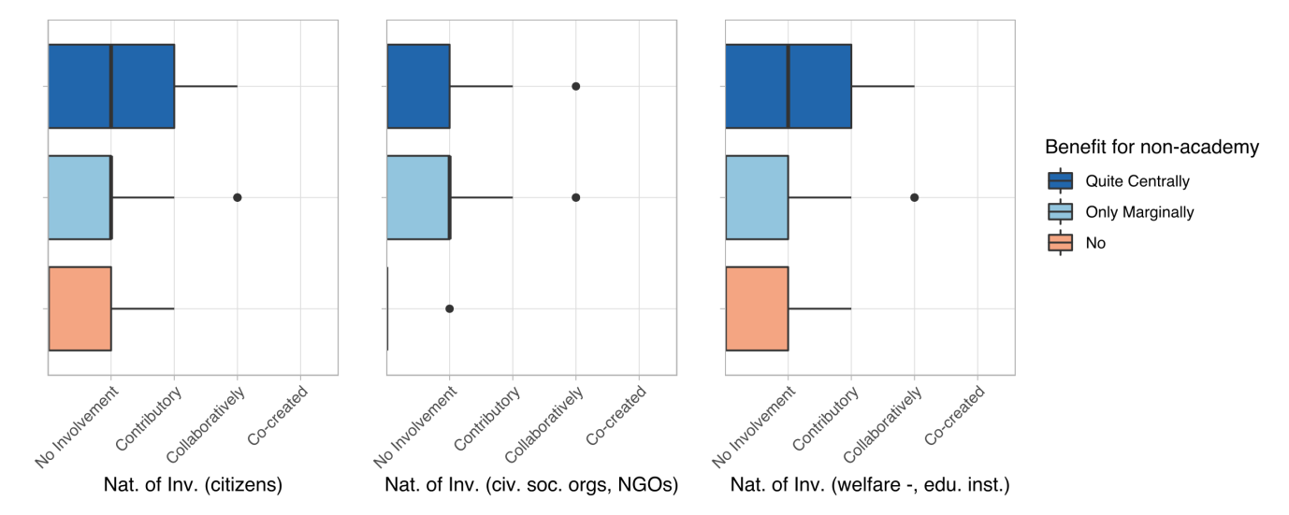

Figure 10: Relation between deliberative design for non-academic benefit and the nature of involvement of...

The nature of involvement of specific groups indicates how far the involvement of those was in the project (for a detailed analysis of the variables see *Nature of Involvement* under Section *Actors & Networks*). Three different societal categories of the *Nature of Involvement,* namely Citizens, civil society organisations & NGOs, and welfare & educational institutions are chosen to test the hypothesis.

The correlation between the deliberative design of the research for the benefit of the non-academic societal groups and the nature of involvement of citizens as well as civil society organisations & NGOs is very weak (rho < 0.15 for each) and not statistically significant. Only the relation between the nature of involvement of the representatives from welfare and educational institutions is significant; however, only showing a weak correlation (rho ~0.3). Although there is a slight relation, deliberative design to benefit specific societal groups does not seem to correlate well with the deeper involvement of the societal groups in the study in terms of transdisciplinary engagement.

## impulse from the non-academic world

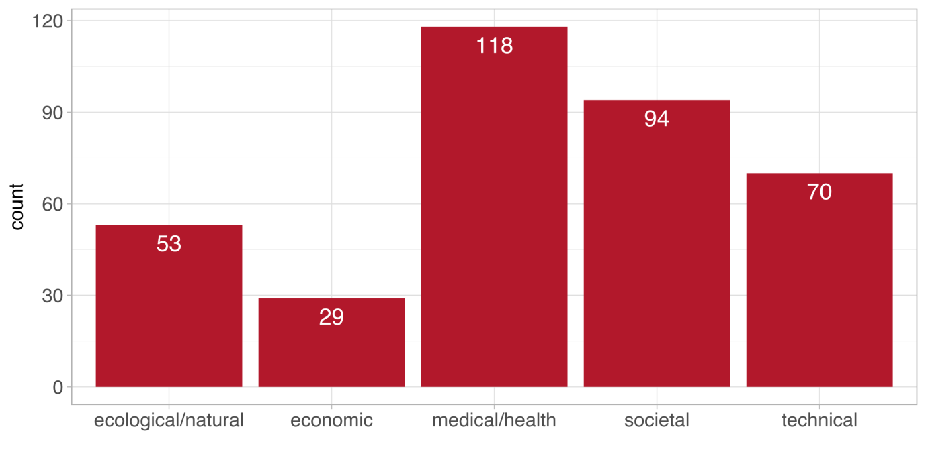

Figure 11: Distribution of impulses from the non-academic world

A further exploration of the impulses that motivated the research concerned which part(s) of the non-academic world was dominant. Medical/health and societal impulses are the most frequently selected ones. On the other hand, economic impulse only rarely motivates an academic research.

# Actors & Networks

## Level and nature of inter-/transdisciplinary involvement

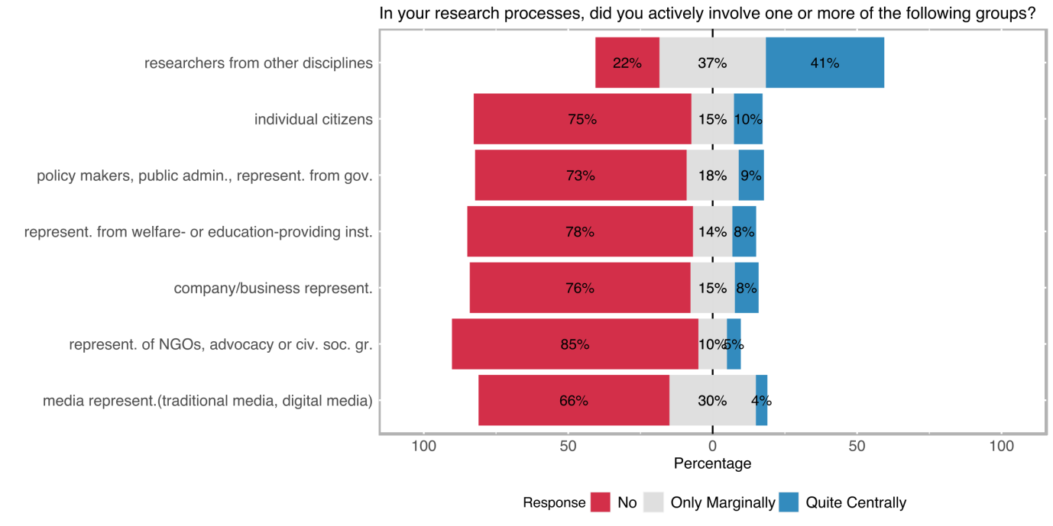

Figure 12: Level of interdisciplinary and transdisciplinary involvement

Interdisciplinary involvement is common among the SNSF funded projects, 41 % of the respondents note that the involvement of academicians from other disciplines was quite central to their specific project (see Figure 10), in total 78 % of the projects were carried out with the collaboration of researchers from other disciplines. Transdisciplinary involvement has been measured under different categories which indicate the inclusion of the different types of societal actors and groups in the research process. Although not as central as the interdisciplinary involvement, different types of transdisciplinary engagement constitute a noteworthy part of the research projects. Transdisciplinary involvement types yield somewhat similar distributions among the projects of the survey respondents.

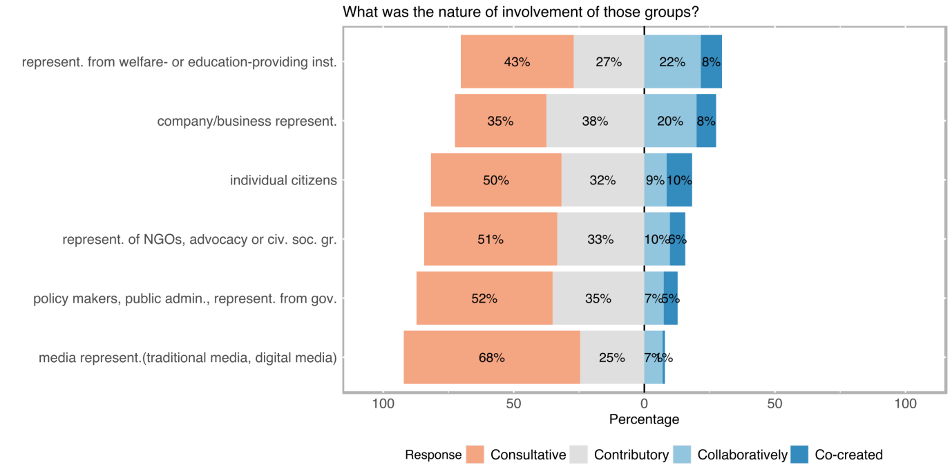

Figure 13: Nature of transdisciplinary involvement

Although the centrality of involvement indicates to which extent specific groups were involved in the project, in the case of transdisciplinarity the role of participating social groups is often overlooked. Motivated by our literature research we have decided that the *nature of involvement* (indicated with the labels; *consultative, contributory, collaboratively, co-created*) carries at least as much information as the centrality of the involvement about the occurrence of SI-related aspects.

Figure 11 displays transdisciplinary involvement mostly consultative or contributory. Collaborative transdisciplinary involvement is relatively more likely when welfare/education institutions or company/business experts are involved in the project (20 % and 22 % respectively). Co-creation is rare in all of the defined transdisciplinary involved categories, the highest co-creative involvement belongs to the projects that include individual citizens (10 %).

Participatory research design is often aiming to mobilise specific social groups’ potential in order to create an action and change by the direct collaboration of those who were affected by the issue being studied[10]. Transdisciplinary involvement of citizens, therefore, is often associated with SI-related outcomes. Therefore, [H] we are expecting more central engagement of the individual citizens with higher levels of SI-Familiarity.

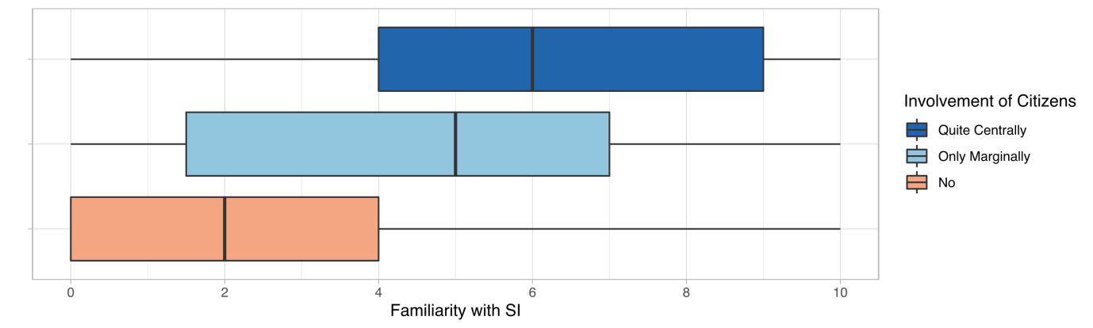

Figure 14: Relation between SI familiarity and the level of involvement of individual citizens

SI-familiarity and individual citizens’ involvement correlate moderately positive (rho ≈ 0.4, p-value < 0.05; see Figure 11). Invididual citizens are more likely to be involved in a project if the researcher is familiar with SI.

Transdisciplinary approaches are often applied to capitalise on the ability of non-academic actors to address a previously unknown or only partially explored issue. The nature of the involvement is an important indicator of what kind of a role transdisciplinary participants played. [H] We are expecting, with further levels of involvement higher levels of addressing a previously unknown (or only partially explored) issue (for a detailed exploration of the variable, see Section *Outcome Orientation*)

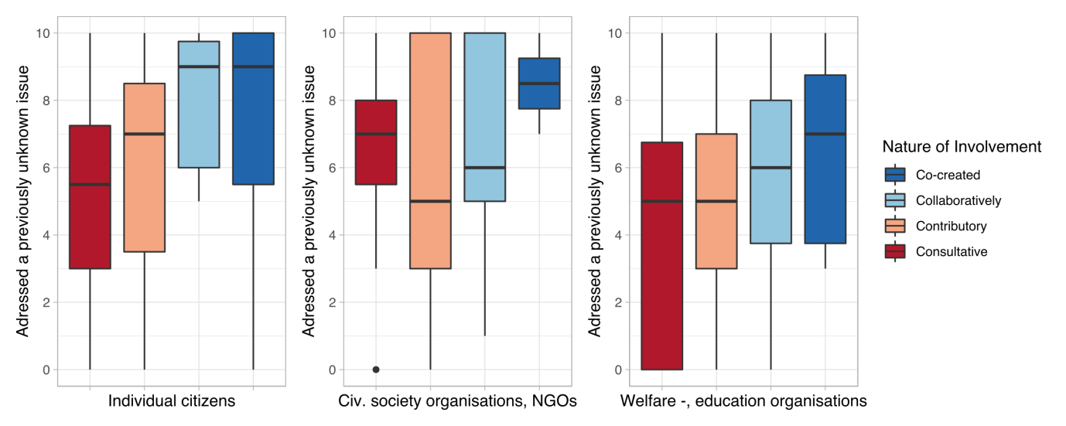

Figure 15: Relation between the nature of involvement of specific societal actors and groups with novelty of addressed issue

The nature of involvement of citizens seems to have a statistically significant relationship with the novelty of the addressed issue (p-value < 0.05), however, it is a weak positive correlation (rho ≈ 0.3). The correlations with other societal groups like civil society organisations, NGOs, welfare-providing, and educational organisations are even weaker (rho < 0.25). In this sense, novelty of the addressed issue does not seem to strongly indicate transdisciplinary involvement of societal groups.

Another expectation from the stronger forms of participatory involvement is to develop wider impacts and scalable solutions. The central involvement of the citizens in the study should allow the creation of more widely applicable results and increased impact for the involved individuals. In this sense, [H] we are expecting the following relations with the *more* *central involvement of individual citizens*:

* scalability of the results[11],
* generating a deeper/better understanding of a specific social issue,
* emancipatory impact of the study on participating groups.

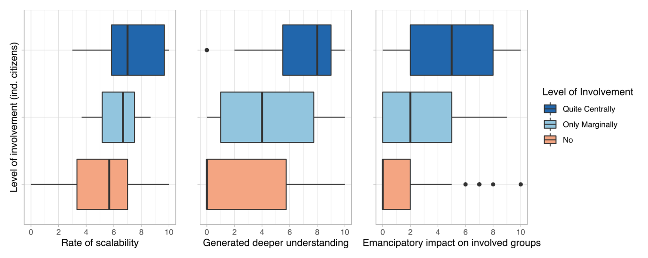

Figure 16: Relation between citizens' level of involvement and selected outcome variables

Scalability seems to be rated slightly higher in the research projects with the central involvement of the citizens (rho ≈ 0.35, p-value < 0.05). Generating a better/deeper understanding as well as the emancipatory impact on the involved societal groups seem to be correlating relatively higher in comparison (rho > 0.45, p-value < 0.05 each). Higher levels of transdisciplinary involvement of the citizens have a statistically significant relation with the scalability of results, deeper/better understanding of the studied issue, and the emancipatory impact on the participating societal actors.

## Target Group Goals

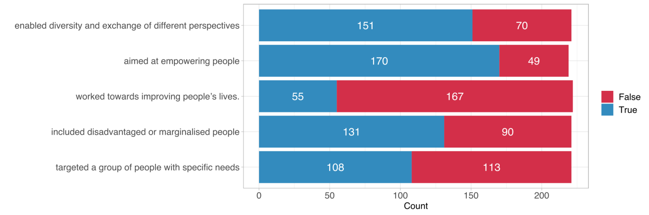

Figure 17: Distribution of target group goals

Envisioned social goals of the project can be important indicators of social innovation. Several true/false statements concerning foreseen social impact and social inclusion goals were directed to measure further aspects of transdisciplinarity. *Aim to empower targeted or included social groups* was the most frequently selected category (170 times) followed by *enabling diversity and exchange of different perspectives* (151 times). The category the project worked towards improving people’s lives was the least frequent selected category (55 times).

# Regulatory Framework

## Open Science Concepts

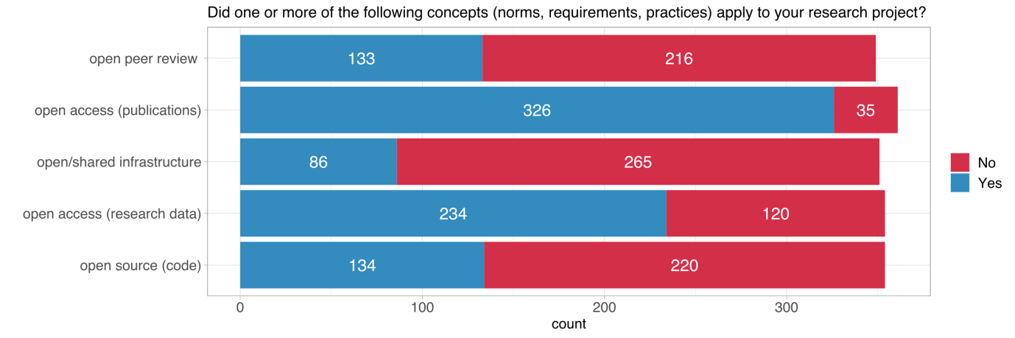

A critical part of carrying out the social goals envisioned in the research process is to ensure project results are available for a broader audience. Therefore, open science practices are important parts of social impact. Survey results display that the most frequent selected category was *open access publication* (326 times, ~ 90 % of the survey respondents), followed by *open access data* (234 times).

Following the dependence of social impact on the accessibility of results, [H] we assume that the number of open access practices tends to rise with higher levels of transdisciplinary experience.

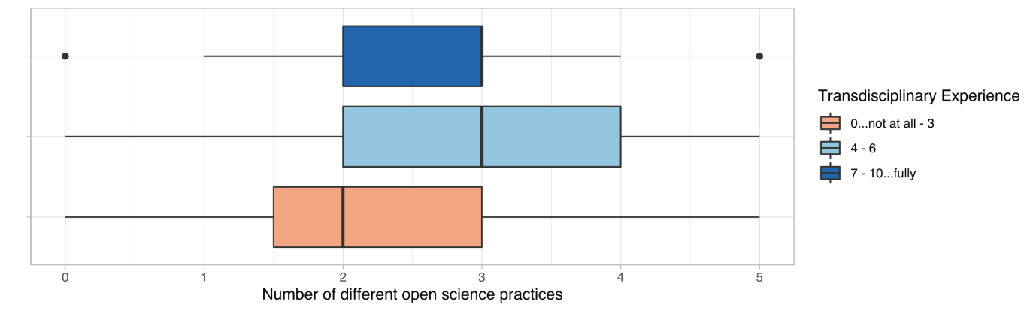

Figure 18: Relation between the number of open science practices and transdisciplinary experience

The analysis yields, however, no correlation between the transdisciplinary experience and the number of applied open science practices as Figure 16 also displays (rho ≈ 0.05).

## Gender Dimension & Support for Policy-Making

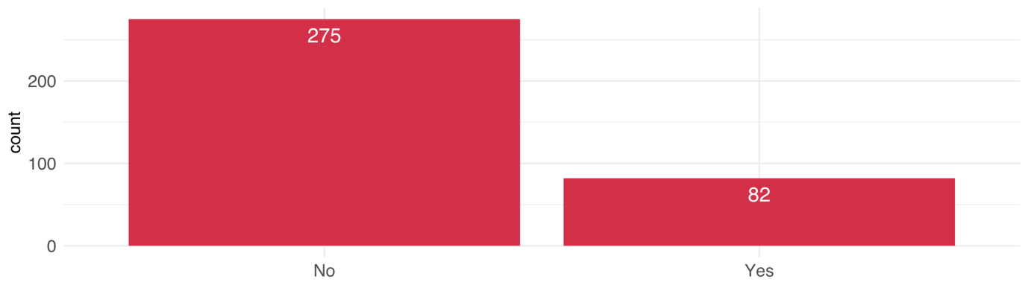

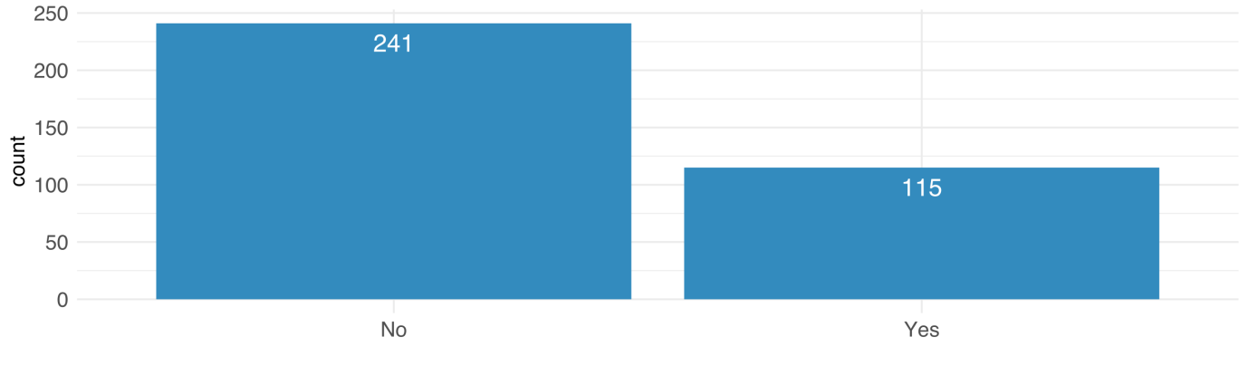

# Outcome Orientation

## Direct Contribution

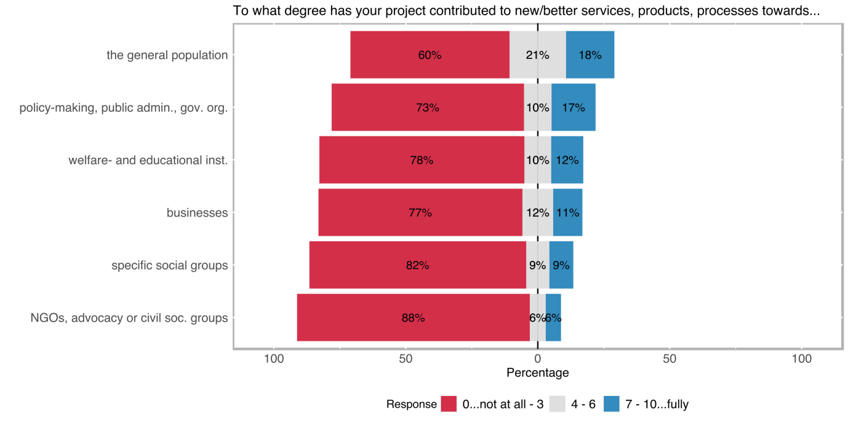

Research projects rarely contribute directly to new services, products, or processes. Although the majority of respondents marked 3 or smaller values on a scale from 0 to 10 for all of the categories, ~ 40 % of the respondents noted that their project results somewhat directly contributed to new/better products and services for the general population from which 18 % of respondents stated to have strongly contributed to benefit the general population.

Our definition of social innovation encompasses outcome orientation which includes both the tangible and non-tangible outcomes. Although the direct outcomes are often rare among the scientific projects, we assume [H] transdisciplinary inclusion of each societal group increases the chances of a direct outcome for that specific group.

## Intended Effects

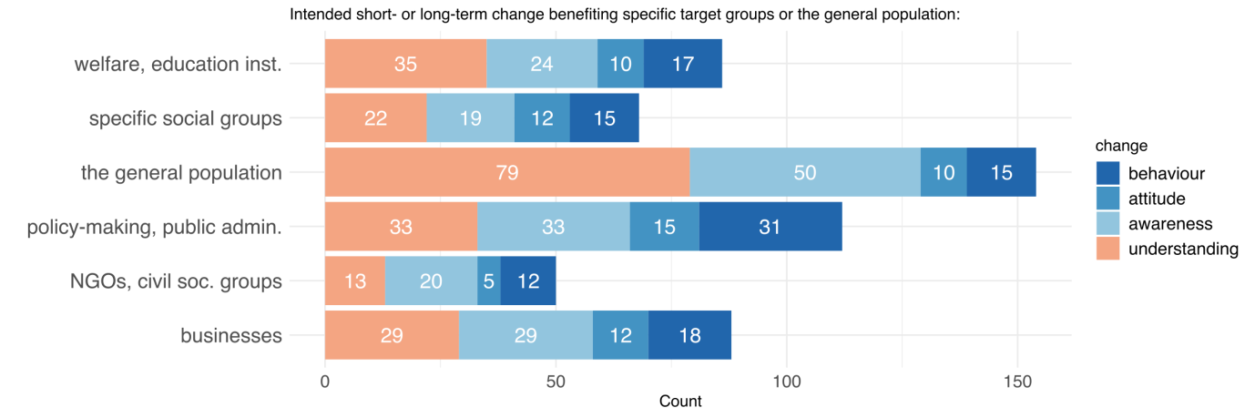

Figure 19: Distribution of intended change

We inquired about intended changes to investigate potential project outcomes, both in the long and short term. *Improving the understanding* as well as *raising awareness* in the general population is by far the most frequently selected category (79 and 50 times respectively). Other arguably stronger types of changes (attitude and behaviour) are occurring relatively less frequent among all of the defined societal actor categories. However, 31 respondents note the intended effect (or one of the intended effects) of their research project was a behaviour change among policymakers and/or public administration.

We assume [H] that the nature of involvement of the societal groups is correlated with the intended effects, or in other words, we are expecting to see a higher order of involvement with higher levels of intended effect for a specific group.

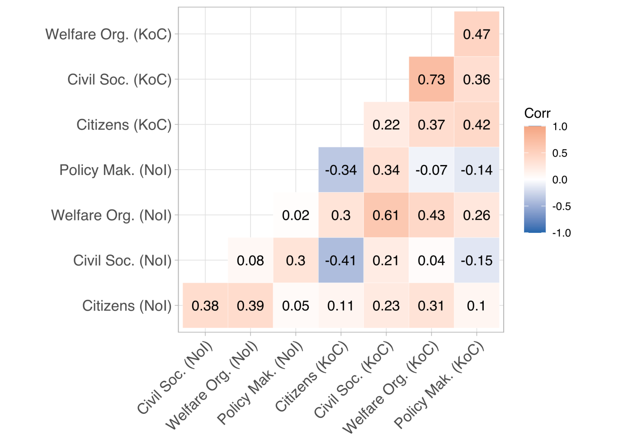[12]

Figure 20: Correlation between the nature of transdisciplinary involvement and intended effects

As the correlation matrix in Figure 18 displays, the nature of involvement of a specific societal group does not necessarily correlate well with the intended effects on that specific group.

## Uptake by Decision-Makers

We measured the uptake of the project results by decision-makers as an indicator of impact. The survey was designed to explore this aspect using two different questions, which were mainly aimed to measure how far the project results have been adopted by the authorities and what was the nature of the uptake.

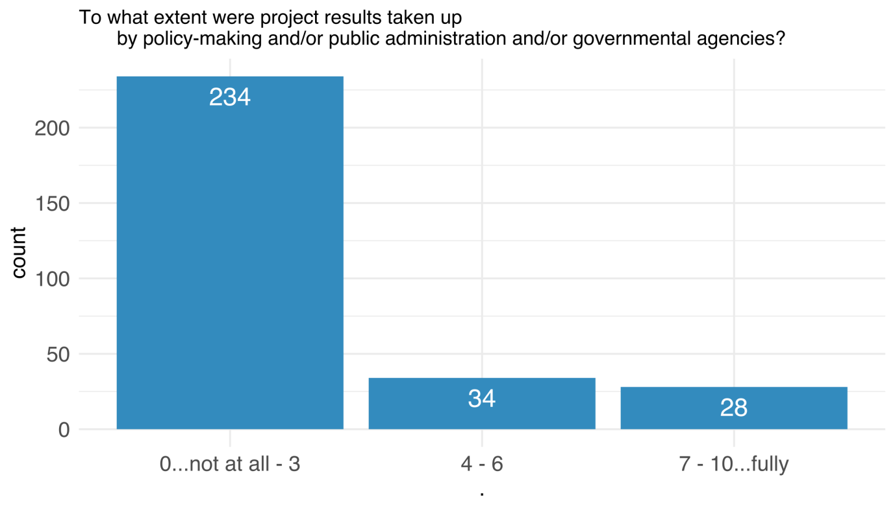

Figure 21: Rate of uptake

Approximately 20 % of the respondents rated the *uptake of the project results by decision-makers* moderate to high. However, an overwhelming majority of the respondents note there was little to no uptake of the project results.

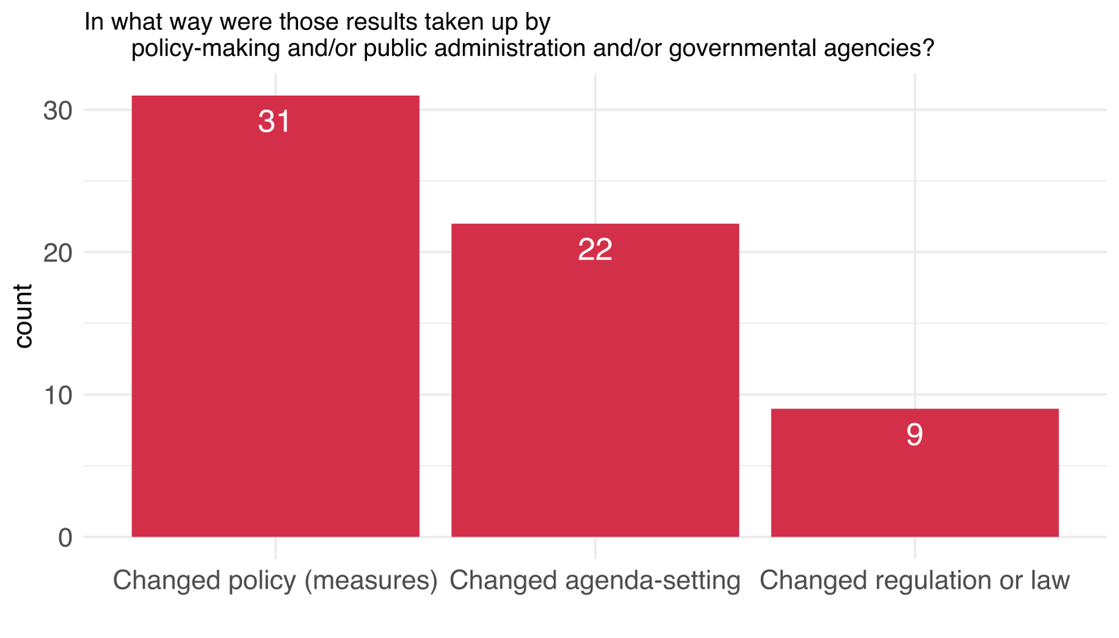

Figure 22: Nature of uptake

The nature of the policy uptake indicates what kind of a change the uptake by policymakers and public administration caused. The response rate to the question is fairly low (~ 17 %). 9 respondents claim that the results of their projects changed/influenced laws and regulations and the other 22 respondents note that the results changed specific agenda-setting.

We assume that [H] the nature of involvement of policymakers have a statistically significant relation nature of policy uptake.

## Impact Statements

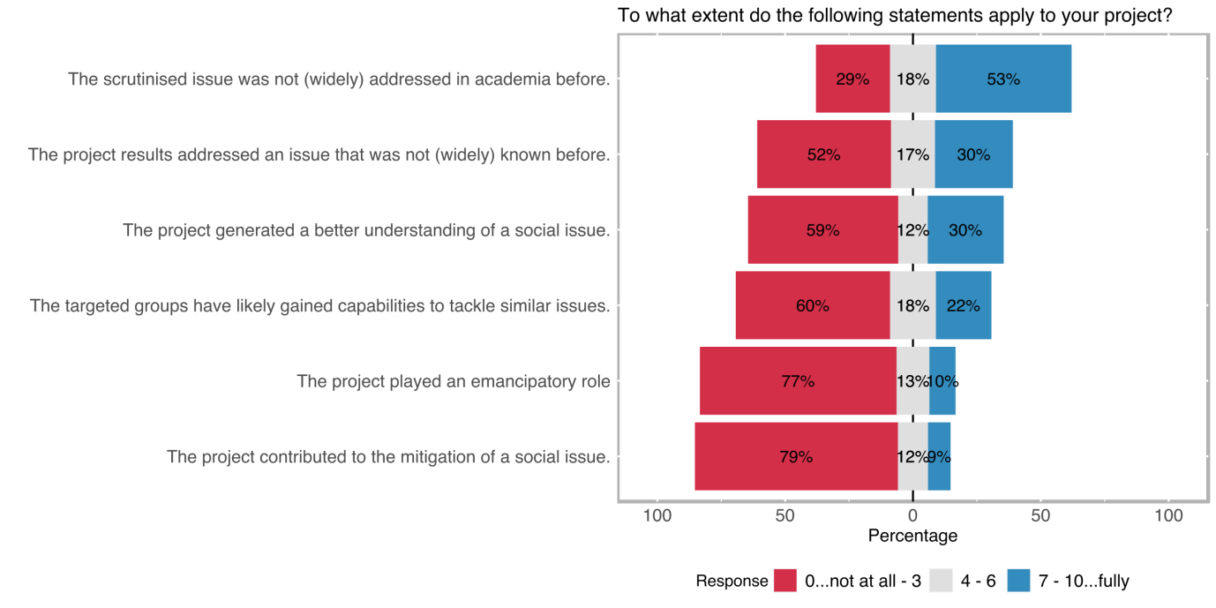

The last question in the outcome orientation section is aimed at state-specific questions about the impact of the project. The statements are chosen to address SI-relevant aspects directly. The academic dimension was by far the highest-rated statement among the survey respondents, 53 % of the respondents rated the statement *the scrutinised issue was not (widely) addressed in academia before* 7 or higher on a scale from 0 to 10. This result is followed by a similar statement *the project results addressed an issue that was not (widely) known before* which was specifically directed to the novelty of the issue for the public, 30 % of the respondents rated this statement 7 or higher, similarly the statement *the project generated a deeper/better understanding of the social issue* was rated from the proportion of the respondents again 7 or higher.

As intention and agency are one of the pillars of the concept of social innovation, especially the strongly social innovation-related statements should at least relate to the deliberative action mobilised by the researchers’ initial motivation. We expect [H] a relation between motivation to improve the human condition with the following statements:

* The project generated a better understanding of a social issue.
* The targeted groups have likely gained capabilities to tackle similar issues.
* The project played an emancipatory role.

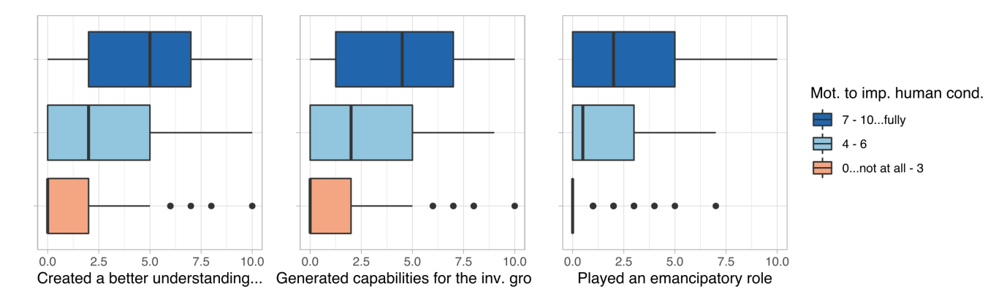

Figure 23: Relation between the social impact statements and the motivation to improve the human condition

There is a moderately positive correlation between the motivation to improve the human condition with each of the analysed impact statement variables (rho > 0.45 each). There seem to be somewhat higher levels in terms of creating a better/deeper understanding of a specific social issue, generating capabilities for the involved social groups to tackle similar issues in the future, and playing an emancipatory role in both participated and targeted social groups with higher motivation to improve the human condition.

# Dissemination and Exploitation

## Dissemination Channels

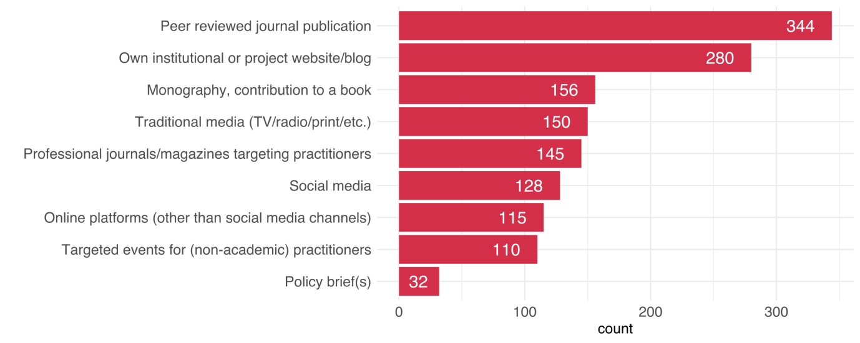

Figure 24: Distribution of dissemination channels

Chosen dissemination channels also deliver important information about the project. Some of the options like peer-reviewed journal publications or the dissemination on the organisations’ own website have unsurprisingly high numbers. Policy briefs were rated lowest but 110 projects stated to have organised events for non-academic practitioners.

## Scalability

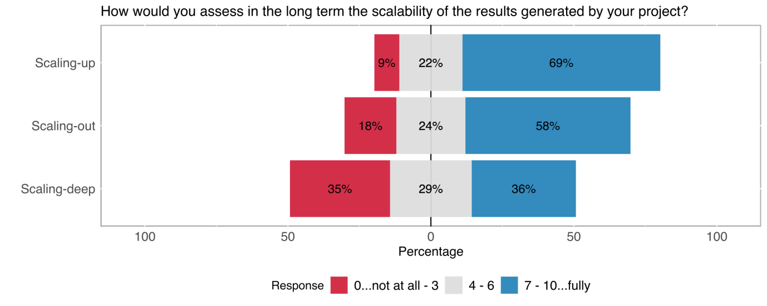

Figure 25: Distribution of scalability

The capability of the generated solutions to be applied in different contexts is another important goal in SI. 69 % of the respondents noted that the solutions generated throughout the project had the high capability to be scaled up.

# Hypotheses

The main focus of the study SIVOCS is to reveal information about the nature of the SI in the SNF funded research. The study has been therefore started with a set of assumptions derived by the literature research, discussion with experts on SI. Creating an appropriate questionnaire to gather relevant information as well as turning those assumptions into scientifically testable hypotheses in order to exploit collected information were one of the core challenges in the study.

This section is dedicated to the presentation of the important findings in the hypothesis testing process. To make it easier to follow the hypotheses are numbered accordingly to the their corresponding variables described in the section 3: *Analysis of the survey questions*.

## SI-Rating and Transdisciplinary Experience Hypotheses

# References

Cargo, M., & Mercer, S. L. (2008). The Value and Challenges of Participatory Research: Strengthening Its Practice. *Annual Review of Public Health*, *29*(1), 325–350. https://doi.org/10.1146/annurev.publhealth.29.091307.083824

Lu, Y., Cohen, I., Zhou, X. S., & Tian, Q. (2007). Feature selection using principal feature analysis. *Proceedings of the 15th International Conference on Multimedia - MULTIMEDIA ’07*, 301. https://doi.org/10.1145/1291233.1291297

Moulaert, F., MacCallum, D., Mehmood, A., & Hamdouch, A. (2013). *The International Handbook on Social Innovation*. Edward Elgar Publishing. https://doi.org/10.4337/9781849809993

1. The term scientific domain is used to refer to the overarching categories of scientific disciplines. SNSF documents already include a specific classification system which we have followed throughout the analysis process, we have also tried to stay consistent with colors associated with each scientific domain on different visualisations. Those categories are as follows:

   Biology and Medicine

   Mathematics, Natural –, and Engineering Sciences

   Social Sciences and Humanities
2. Literature on this topic goes as far as stating that transdisciplinary aspects are central (and necessary) to SI-related research. For a detailed discussion about the topic see (Moulaert et al., 2013)
3. A detailed analysis of these variables can be found in Section 3 Intention & Agency*.*
4. After the consideration of dominant variable types and distributions, as well as the often non-linear relationship between variables, Spearman correlation was chosen as the method to be applied in the analysis of most of the survey data. The correlation coefficient is indicated by the English spelling of the common symbol of Spearman’s rank correlation coefficient symbol **ρ**, i.e. **rho**. The reason for this is to clearly distinguish between **ρ (rho)** and **p**, as in **p-value** that is often be mentioned in parentheses.
5. Study wide α value is 0.05..
6. Kruskal-Wallis method is a non-parametric alternative to ANOVA.
7. Results of the pairwise comparisons using Wilcoxon Rank Sum Test with continuity correction (Bonferonni) p-value adjustment yields a p-value greater than 0.05 for Mathematics, Natural-, & Engineering Sciences. SSH, however, associated with p-values significantly smaller than 0.05 in comparison with both of the other domains. Wilcoxon Rank Sum method can be used as a non-parametric substitute for pairwise t-test.
8. A statistical model has been built to assess the rate of SI through the important variables in the survey results.
9. For a detailed analysis of the variables, see Section 6 Outcome Orientation*.*
10. (Cargo & Mercer, 2008)
11. The concept of scalability has been operationalised under 3 different categories in the survey (deep -, out -, and up scalability), however, after a dimension reduction process in the analysis (explanatory and confirmatory factor analysis), it has been decided to compile the sub-variables of scalability into one single scalability variable because of the similarity of their explained variances. Either because of the similarity of concepts or because of the lack of the knowledge on different forms of scalability the responses under different categories were highly similar (or because of common method bias …) .
12. Noi: Nature of Involvement.

    KoC: Kind of Change.